**Tutorial 7**

**Home Page**

Started with the code from the Library Management System provided by the class tutorial. Developed a new Customer Management System Schema, updated the pages to reflect the new schema and eliminated “book” by replacing it with “customer” in the code and the filenames. The following screenshot shows the initial page with some test data included.

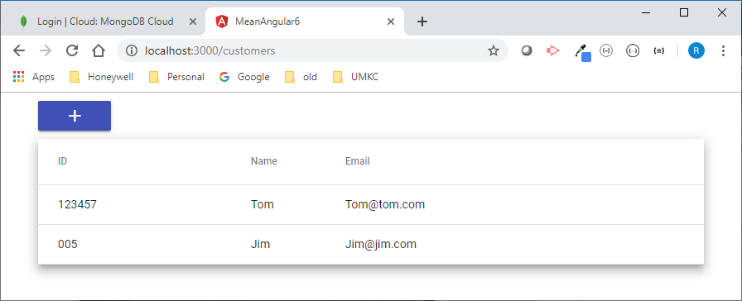

**Create Customer Page**

If the user selects the “+” button, they will move to the Create Customer Page. This page will allow the user to create new customer and add it to the DB and the Home Page details.

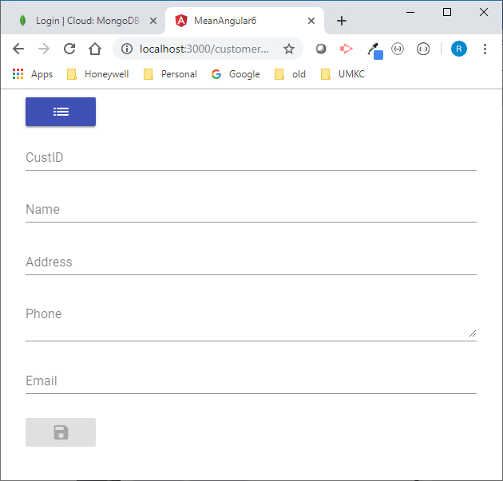

If the user selects a field but does not enter any info before moving to the next field, the field will change to red font and display a request for the user to enter the data for the field. This shows each field after it was selected without entering any data.

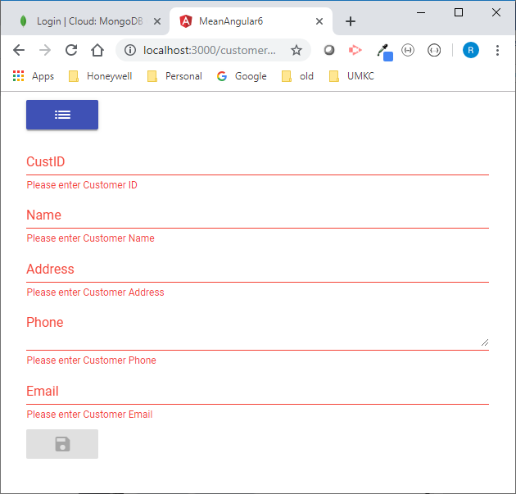

**Customer Details Page**

After submitting a new customer or if the user selects one of the rows on the Home Page, they will see the details for that customer. They are given the change to Edit or Delete this customer via two buttons on the bottom of the display. The hamburger button (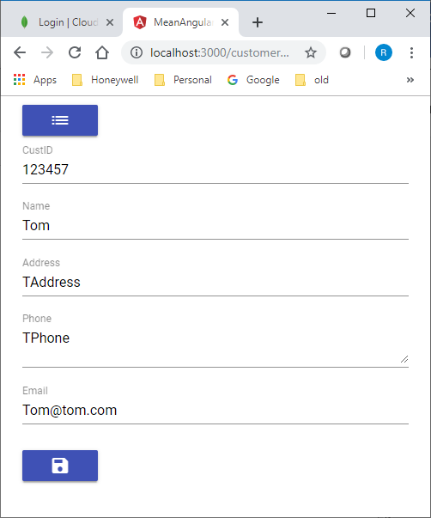) at the top of the display will move them to the Home Page.

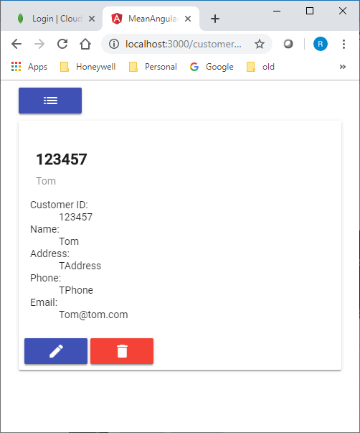

**Customer Edit Page**

If the user selects the Edit button on the Customer Details page, they are moved to the Customer Edit Page. They can make any changes to the data and select the Save button at the bottom of the page. Once again, the hamburger button at the top of the display will move them to the Home Page.

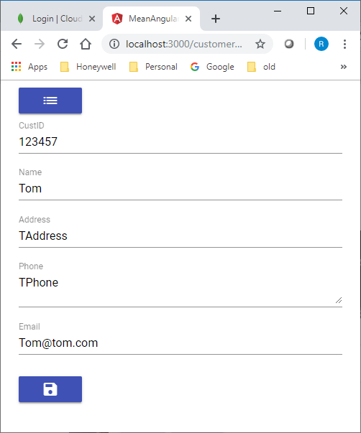

**MongoDB Atlas (MLab) Database**

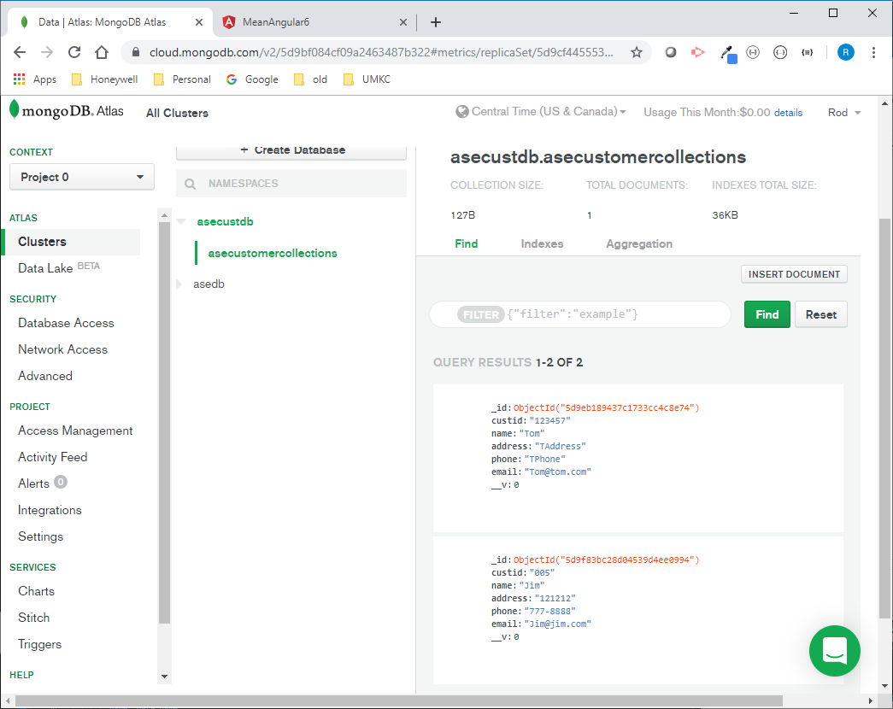

**Contribution**

**Lab ID: 3_2**

Dukkipati Sri Sai Nithin Chowdary (Class Id 05)

* Design and testing the application. Caught some key issues with meeting some of the key requirements.

Rod Skoglund (Class Id 23)

* Coding and Mongo Atlas (MLab) creation and design.